**Task :**

Using Lambda Function to Start & Stop the EC2 Instance Using Cloud watch Events.

1) Create function to start ec2 instance at 10 AM IST if instance has tag ec2_start = "true".

2) Create function to stop ec2 instance at 10 PM IST if instance has tag ec2_stop = "true".

3) Outcome is ec2 instance should start or stop automatically based on cron job schedule.

**Solution**

**Step 1:**

1. Launch EC2 instance
2. Sign in to the AWS Management Console.
3. Click on the EC2 service.
4. Click on the Launch Instance button to create a new instance.
5. image.png
6. Add the tag ec2_start and ec2_stop

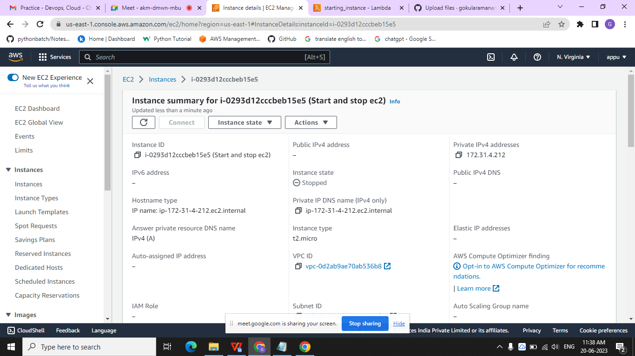

**Step 2 :**

1. Creating IAM Roles for a service
2. In the navigation pane of the console, click Roles and then click on "Create Role".The screen appears shown below on clicking Create Role button.
3. Choose the service and create policy to start instances and stop instances.
4. Select the managed policy that attaches the permissions to the service.
5. In a role name box, enter the role name that describes the role of the service, and then click on "Create role".
6. 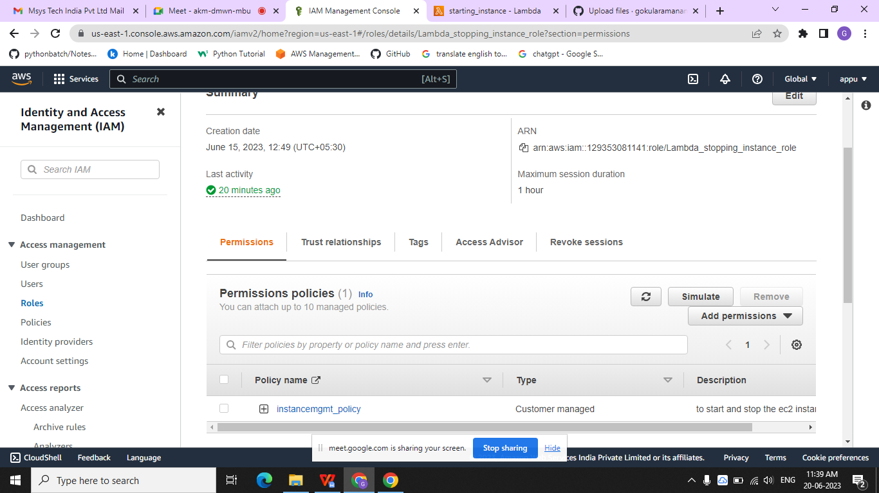

**Step 3 :**

1. Creating Lambda function
2. Click on the Lambda service.
3. Click on the Function appearing on the left side of the console.
4. Click on the Create function to create a new function.
5. Now, we create the Lambda function by using the Author from scratch.
6. I created a new role, and my role name is ec2_start_stop
7. Click on the Create function.
8. You can configure triggers.
9. 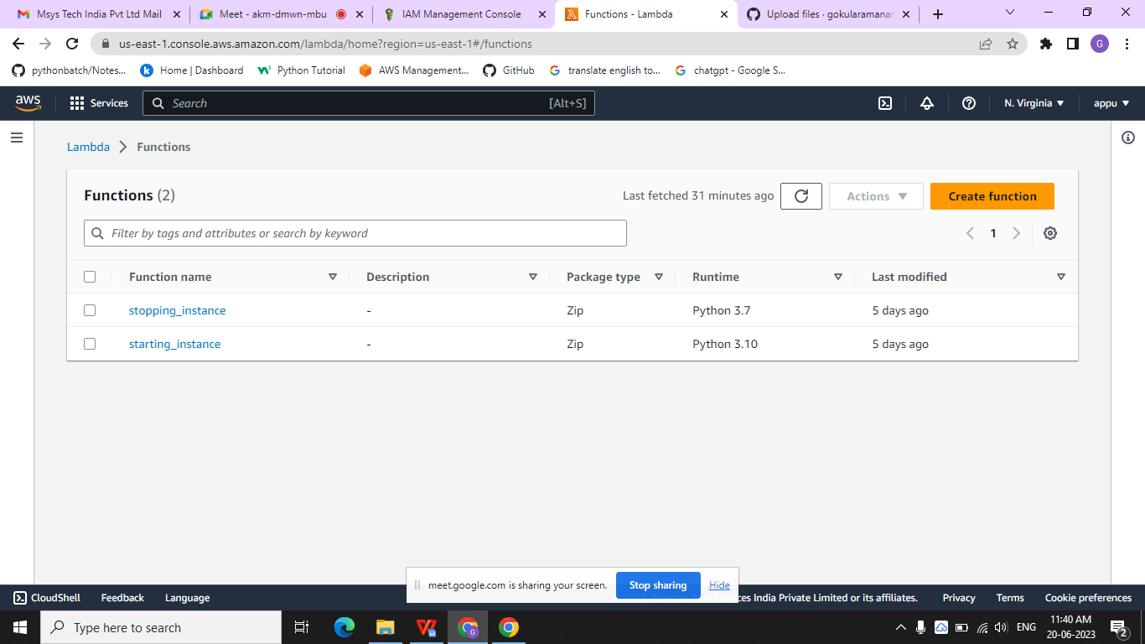

**Step 4 :**

1. Creating Cloudwatch rule for triggering
2. In the navigation pane, choose Events, Create rule.
3. For Event Source, Choose Schedule(Cron job).
4. For Targets, choose Add target, Lambda function.
5. For Function, select the Lambda function that you created.
6. Choose Configure details.
7. For Rule definition, type a name and description for the rule.
8. Choose Create rule.
9. 